21EIC551J - FUNDAMENTALS OF ROBOTICS
Formative Assessment – II Mark : 60
Date : 12.11.2025 Answer Any three Duration : 120 minutes

- Formulate the direct kinematic model of the six degrees of freedom Stanford manipulator shown in figure.
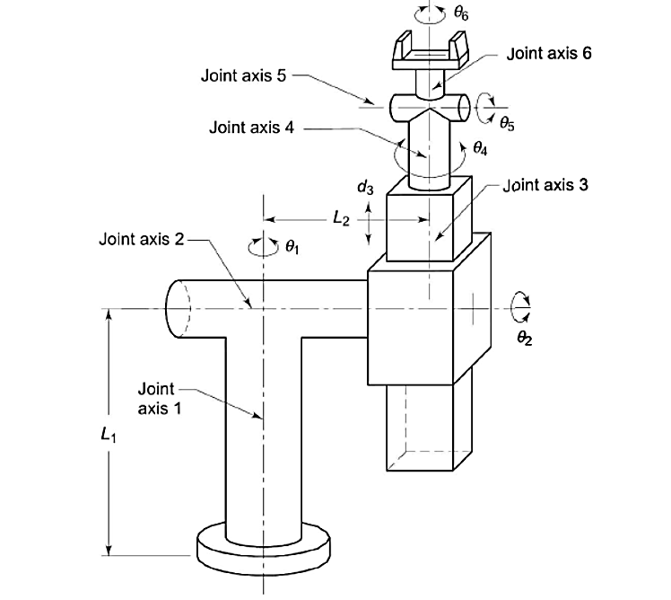

- For the 3-DOF articulated arm shown in figure, determine the joint variables for the known position and orientation (T) of the end of the arm point.
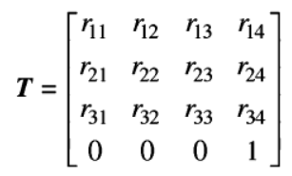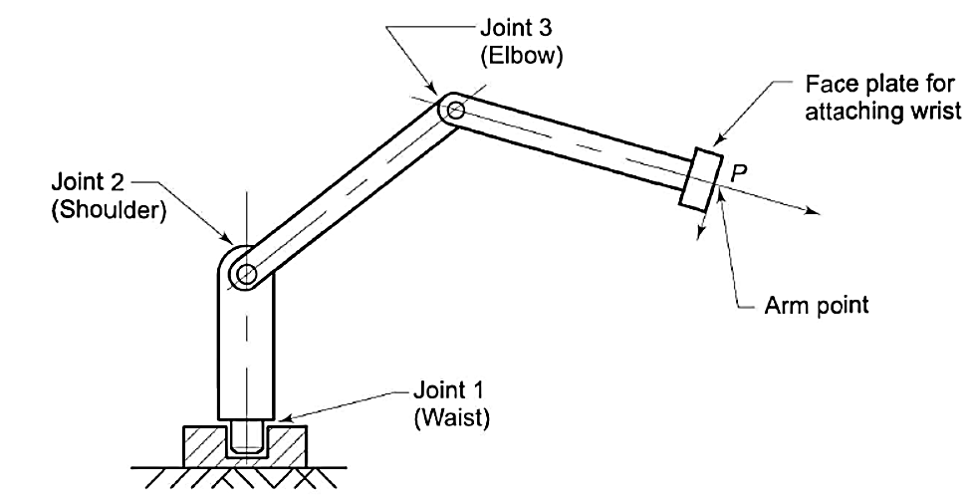

- Using the Lagrangian method, derive the equations of motion for the 2-DOF robot arm, as shown in Figure. The center of mass for each link is at the center of the link. The moments of inertia are I₁ and I₂.
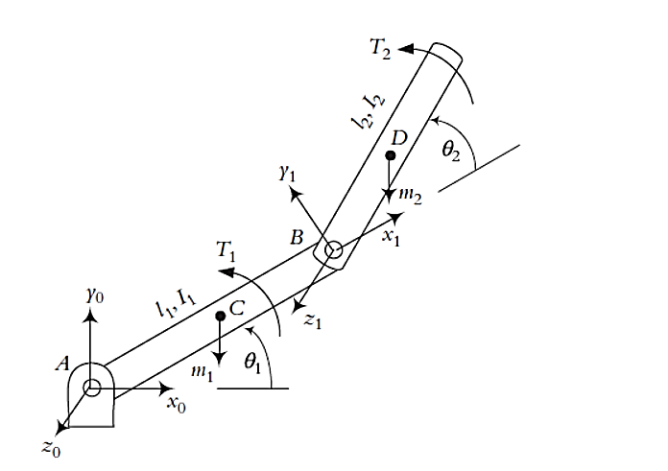
- An autonomous drone for monitoring farms is being built by a robotics firm. The drone must be able to tell how healthy the crops are, find weeds, and go around fields on its own. Explain how the drone's robotic system can use computer vision to do these things. Talk about how image segmentation, classification, and real-time decision-making fit into this context, and point out any possible problems and ethical concerns.

